

VERTICAL DIFFUSION PM PROCEDURE (OXIDE)
PM Type: YPM Prepared by:
Machine: OXIDE Robin 羅彬森
PM Frequency: 1 year S200 FURNACE
Date: May 2017

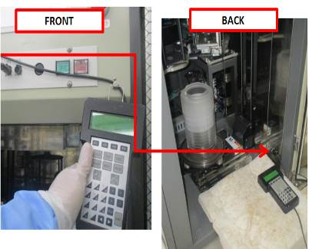
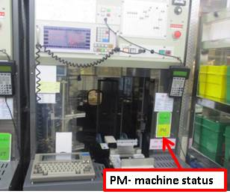 |  |  |  | 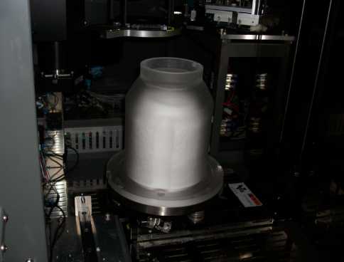
1. Confirm if machine ready for PM, Check status |  | 2. Get controller from front of machine, and connect to back terminal on lower right side. |  | 3. Remove pedestal cover

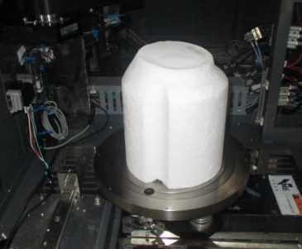 |  | 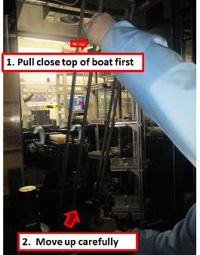 |  | 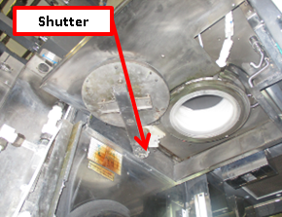
4. Remove Pedestal |  | 5. Remove boat |  | 6. Remove back machine cover, and remove shutter and cover

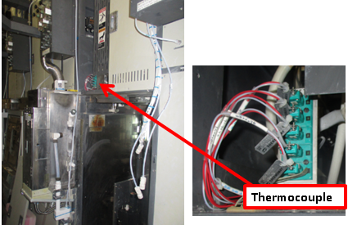 |  | 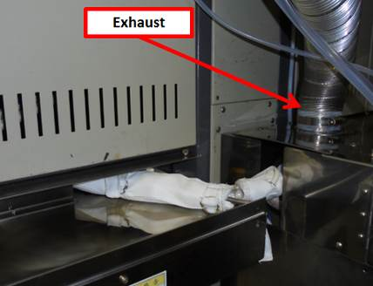 |  | 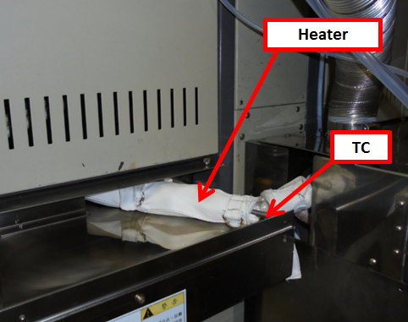
7. Remove upper cover and disconnect TC connector |  | 8. Remove exhaust utility duct and cover |  | 9. remove pipe heater and TC

Doc. #: 2017-CRP-007 rev.00 Page 1 of 4

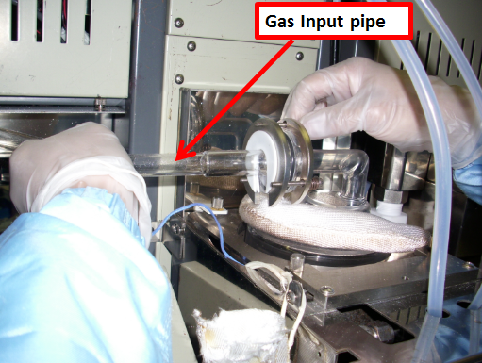 |  | 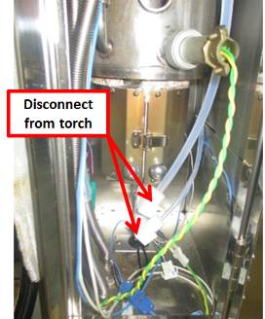 |  | 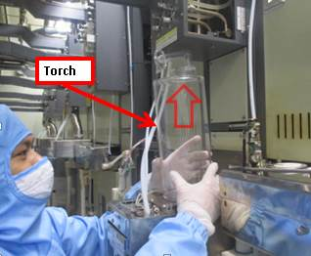
7. Remove gas IN pipe tube |  | 8. Remove torch gas hose |  | 9. remove torch

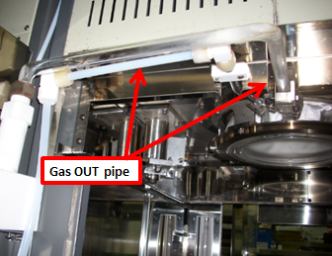 |  | 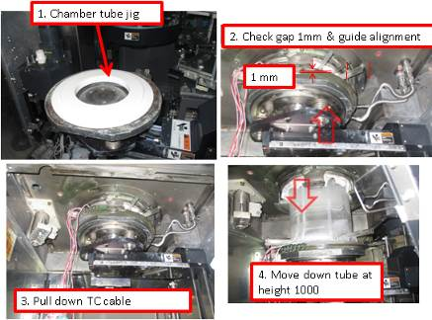 |  | 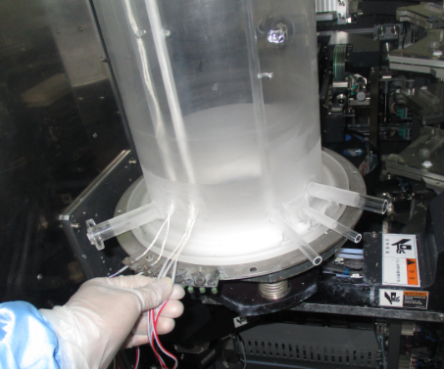
10. remove gas exhaust pipe |  | 11. Using jig unlock inner tube and bring down at M01 height=1000 |  | 12. remove TC at and bring down chamber tube TC (4,5) + (1,2,3)

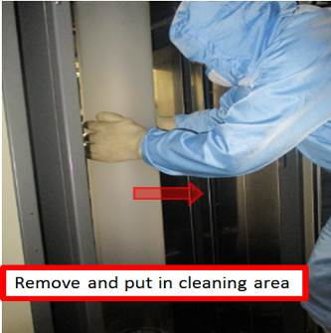 |  | 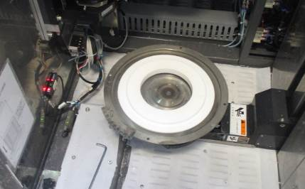 |  | 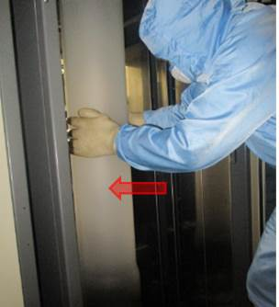
13. Using safety gloves remove chamber tube and bring to cleaning area using push cart. |  | 14.. Clean manifold and Tube lock ring |  | 15. Install chamber tube

 |  | 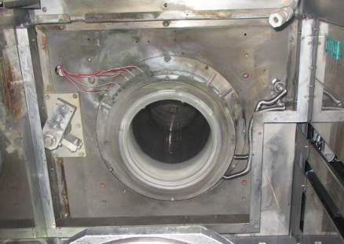 |  | 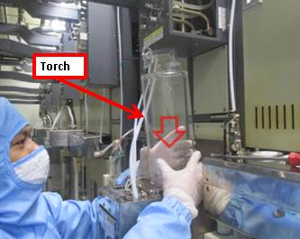
16. Move elevator up at Ht.1000 and install TC (4,5) + (1,2,3) |  | 17. Move elevator up and lock Chamber tube and connect heater. Then bring down lifter to P01. |  | 18. Install torch

Doc. #: 2017-CRP-007 rev.00 Page 2of 4

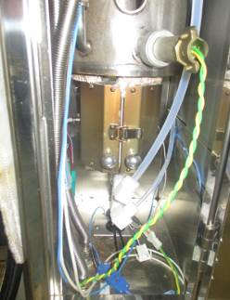
19 connect torch gas hose |  | 20. connect gas Input tube |  | 21. connect exhaust pipe

22. Connect pipe heater, cover and exhaust duct |  | 23. clean chamber cap and Install pedestal |  | 24. Install Pedestal cover

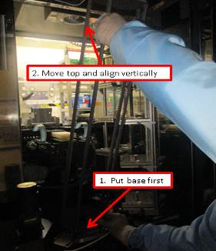 |  | 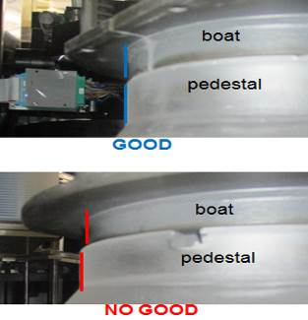 |  | 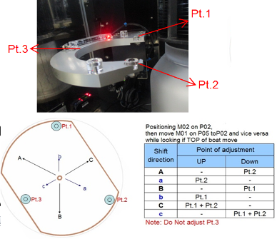
25. Install boat |  | 26. Put M06 in P01, put boat on top of pedestal and check alignment |  | 27. while M02 is in P02, Move M01 between P02 and P05, adjust if top of boat move

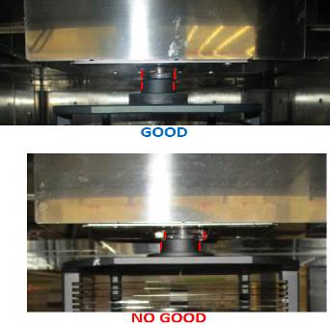 |  | 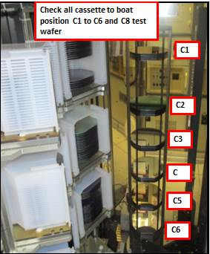 |  | 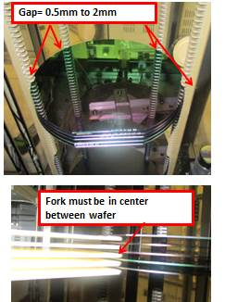
28. Put M02 in P01 to check/adjust boat lock |  | 29. Put boat M02 in P01 to do Transfer check. Load dummy wafer |  | 30. Check/adjust wafer position on boat, and fork gap between wafers

Doc. #: 2017-CRP-007 rev.00 Page 3of 4

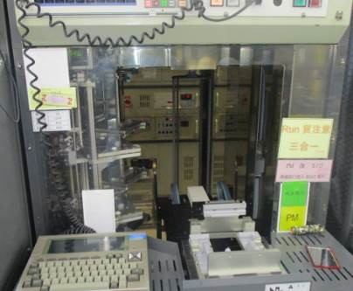 |  |  |  | 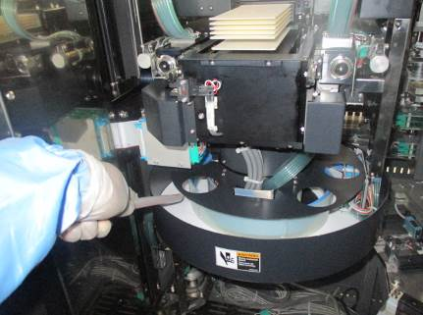
31. Unload dummy wafer and cassette. |  | 32. Install shutter cover, check shutter movement. |  | 33. Clean and Vacuum inside machine and Transfer robot area before close machine
I
EA TEST RUN
34. fill up machine log book PM OK and endorse to EA for test run

Doc. #: 2017-CRP-007 rev.00 Page 4of 4

